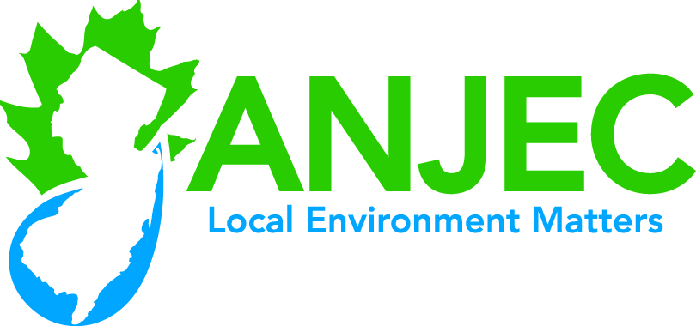

Application Blank

2022 ANJEC Open Space Grants for Environmental Commissions Application

Municipality: County: Phone:
Mailing address of municipality:
Environmental Commission Contact Person (person responsible for application):
Name: e-mail:
Home address: Day and cell phones:
Environmental Commission Chairman
Name:
Day or cell phone: e-mail:
Municipal Manager/Administrator
Name: e-mail: phone:
Year Environmental Commission was established by ordinance:
Is your Commission a member of ANJEC? Yes / No
Is this project site on/near remediated site: Yes/No

Title of Project:
Amount being requested from ANJEC:

Project description (Limit 900 words): What will you do? Who? When? How? Objectives? – Address and number items #1 – 6 on “How applications will be evaluated.”

Project budget (Limit one page): See item #2 of “How applications will be evaluated.” Include an estimated breakout of the in-kind (volunteer and town staff) labor. If additional labor, cash or other contributions are being used, itemize them in the budget. See requirement for letter from municipal administrator/manager under “Applications due” above.

***In addition to the application, applicants must submit a scanned, dated and signed letter from the municipal manager or administrator indicating endorsement of the application and assuring payment of any additional costs that are included in the budget.

***Send the letter as a separate attachment to info@anjec.org by the application due date, Monday, May 2, 2022. ANJEC will confirm receipt of your application file and letter file.

